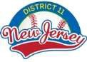
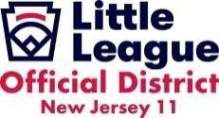
2025 District 11 Champions

LL (12) Baseball Champion | LL(12) SOFTBALL CHAMPION
South Wall Little League | North Wall Little League
8-10 Baseball Champion | 8-10 SOFTBALL CHAMPION
North Wall Little League | North Wall Little League
9-11 Baseball Champion | Junior Baseball Champion
North Howell Little League | Howell Central
Senior Baseball Champions | 7 yr old District Champion
8 yr old District Champions | 9 yr old District Champions

